PreciFarm

(Integrated Wired and Wireless IoT Solution for Precision Agriculture)

1Anil Jaysingh Rajpurohit*,* 1Arpit Ajay Shrivastava, 1Vaishnavi Patil, *BE-EnTC, VIIT Pune*

2G.H. Chavan, Professor, EnTC, VIIT Pune

Narendra Rajpurohit, Co-Founder, Ni logic Pvt. Ltd., Pune

***Abstract -*** *This paper refers an Integrated wired and wireless IoT Solution for Precise Agriculture named as PRECIFARM. In farming maximum production requires parameters such as soil moisture, soil temperature, soil conductivity, soil salinity, soil PH, air moisture, air temperature UV and light to be precise for proper crop productivity, avoid conditions for pest growth, preventing pests and reducing wastage of resources.Covering the per hectare area of farm and maintaining the precision in data are two factors that are very important.* *PRECIFARM will work as integrated inhouse solution for crop related problems.*

*With latest technologies like LoRa (Long Range Low Power), WSN (Wireless Sensor Network), AES Secured payloads, Django based DBMS (Database Management System), Advanced JSS, Bootstrap 4 and calibrated sensors. PreciFarm focus on providing precision, security, interactive interface and reliable solutions.*

*Agriculture in today’s world holds the utmost importance and working towards its precision is our duty. This is a small attempt by us where we have applied our Engineering knowledge practically for a better green life tomorrow and a happier farmer today.*

***Keywords— Smart, Precision Farming, Gateway, Sensor Nodes, Crop yield, Pest Control, Irrigation, Internet of Things, Database, Cloud.***

1. **INTRODUCTION**

IoT has the capability to influence the world we live in; advanced industries, connected vehicles, and smarter cities are all components of the IoT equation. However, applying technology like IoT to the agriculture industry could have the greatest impact. In today’s world farming is something which dates many problems. The need of the hour is to automize farming and use the trending technologies to solve the major issue. Against the challenges such as extreme weather conditions and rising climate change, environmental impact, wastage, no proper monitoring, unproductive yield resulting from intensive farming practices, the demand for more food has to be met.

PRECIFARM is an Integrated wired and wireless IoT Solution for Precise Agriculture aimed at solving problems using latest technologies available.

Precision farming based on IoT technologies will enable growers and farmers to reduce waste and enhance productivity ranging from the quantity of fertilizer utilized to the number of journeys the farm vehicles have made. This Project uses WSN (Wireless Sensor Network) to cover large area fields, along with our own Cloud with latest development tools like Django platform for making User Interface Better and customized for the use.

1. **LITERATURE SURVEY**

In farming maximum production requires certain parameters to be precise and some of them are Soil moisture, Soil temperature, Air moisture, Air temperature, UV and light. The idea of precision farming exists from around 1994 and has gone though many advancements over the last decade. Researchers have also included concepts of IoT and cloud computing to detect pests [1].

Its major goal is to avoid wasting the crops from plant life and microorganism diseases like “eyespot”, “Pseudomonas Syringae”, “Phomalingam”, “Leptosphaeria Maculans”, “Alternaria-Dligst” and “Phytophthora”. the atmosphere conditions like ratio and temperature area unit important elements to the unfold of unwellness. thus, sensors area unit positioned in whole cultivate field to observe the microclimate the wet or temperature during a precise space, particularly once this is often} numerous from the weather or temperature within the neighborhood encompassing it can be closely monitored [2].

1. **Soil Salinity**

Too much soluble salt in the soil, the soil water potential was decreased with the increase of osmotic potential. Based on the principle that water flows from high water potential to low water potential, the water potential of the root cell must be lower than the water potential of the surrounding medium, so the soil salinity is higher, the root water absorption is more difficult. As evaporation strengthened, salt damage is more serious, the abnormal growth of plants, Plant short stature, leaf small dark green, like drought. Plants have been excluded from the absorption of other nutrients because of absorbing excessive certain salts. Too much salt can inhibit the synthesis of chlorophyll and the occurrence of various enzymes in the photosynthetic apparatus Destruction of normal metabolism. Salt stress directly affects the membrane lipid and membrane protein, the membrane permeability increased and membrane lipid per oxidation, thereby affecting the normal physiological function of the membrane. The effect of excessive salt on protein metabolism is obvious.

1. **Soil Conductivity**

Understanding of water and salt dynamics and its harm to crops, provide reference for the prediction of soil salt, the forecast, in order to take effective measures to ensure normal crop growth. Understand the comprehensive control measures the effect of saline soil. According to the soil salt content and its composition, saline soil classification, and make reasonable planning, in order to achieve reasonable planting, the purpose of reasonable irrigation and drainage. For irrigation water quality appraisal, determination of the salt content in irrigation water, so that the rational utilization of water resources, land reclamation, prevent soil salinization.

1. **Soil Moisture**

Plant photosynthesis and dry matter accumulation by water supply, the amount of accumulation is directly reflected in the plant height, stem diameter, leaf area and yield formation. Leaves are the main places for photosynthesis and transpiration. The mesophyll cell expansion and leaf growth are very sensitive to water conditions. Crop yield is the accumulation of solar energy into chemical energy on the crop. Plant root is the main organ of water absorption, its development is affected by many aspects, but the main function are soil moisture condition and ventilation condition.

Calculation of Soil Moisture

Soil Moisture sensor is deployed at the distance downward of 1cm to 3 cm. To calculate the soil moisture of diverse types of soils, soaring frequency is use by mote. Following is the

equation used to calculate the soil moisture [12]. $$C=∈r*(A/D)$$

Where: -

C - Capacitance

A - Overlapping area of plates

- Dielectric Constant of the material within the plates.

D – Distance between the plates.

Photosynthesis is the main source of energy for green plants. The size of photosynthetic rate is closely related to the water status of plants.

1. **PROPOSED METHODOLOGY**

Arable farming defines cultivation of crops, which includes growing, maintaining and yielding of crops. Modules mentioned below makes this system a precision farming system-

● Automated calculation of crop yield.

● Automatic watering of field.

● Timely reporting of disorder.

● Automatic pesticide application.

As this system tries to minimize complexity for the farmers, some core features have been added only. Automated calculation of crop yielding needs a number of Temperature, Humidity and Crop moisture sensors installed. Counters are also needed to count the number of ripe crops. This equipment will function together and will transfer signals to one another [3].

Automatic watering of the field needs installation of pH sensor, Temperature sensor, Moisture sensor. The actuators for this particular feature are water pump, servo motor and power supply (5 volt). PH sensor calculates the nutrient index of the soil. Moisture sensor measures the dielectric constant of the soil. The higher dielectric constant indicates higher moisture. Water pump supplies water to the field and servo motor controls the movement

of the pipe, it rotates the water pipe from 0 to 180 degrees for equal distribution of water throughout the field. Based on pH level value, moister and temperature the actuators will decide the movement of servo motor and amount of water to be supplied according to coverage area of crops. Ideal range for temperature sensor is 450-800 Ohm, for moisture sensor it is 300-700Ohm and Ideal pH range is

5.5-7.0. If the values collected from the sensors are higher than the mentioned range, then servo motor will water the crops [4].

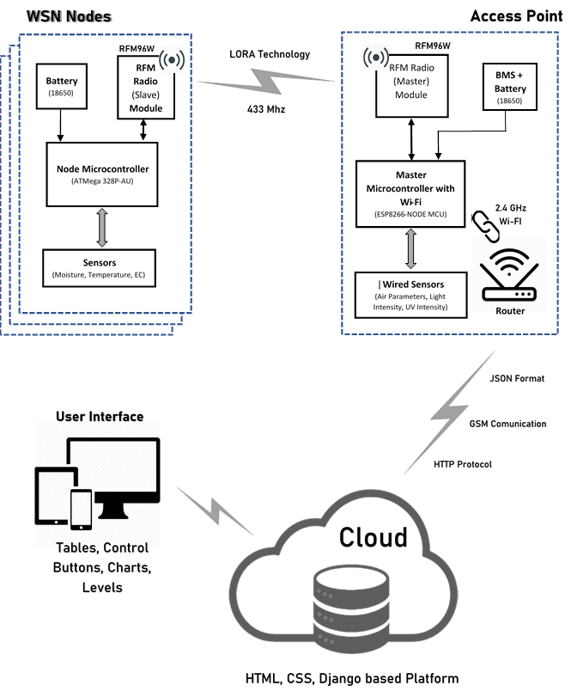

**Figure 3.1**

This project can be divided into three parts:

1. **Data Generation** – Sensors are used to generate data as follows:
2. **Soil Sensor**

The electrical component known as a capacitor consist of three pieces.  A positive plate, a negative plate and the space in-between the plates, known as the dielectric. A capacitive moisture sensor works by measuring the changes in capacitance caused by the changes in the dielectric. It does not measure moisture directly (pure water does not conduct electricity well), instead it measures the ions that are dissolved in the moisture. These ions and their concentration can be affected by a number of factors, for example adding fertilizer for instance will decrease the resistance of the soil.  Capacitive measuring basically measures the dielectric that is formed by the soil and the water is the most important factor that affects the dielectric. The final output value is affected by probe insertion depth and how tight the soil packed around it is. Value_1 is the value for dry soil and Value_2 is the value for saturated soil.  
For example: Value_1 = 520; Value_2 = 260.  
The range will be divided into three sections: dry, wet, water. Their related values are: Dry: (520~430), Wet: (430~350), Water: (350~260).

Linearity in such sensor need to be assumed[5]

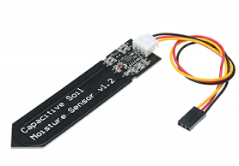

1. **REFERENCES**

* [1] Smart Board for precision paper
* [2] amit kunal

[3] [Smart Board for Precision farming]

[4] [11 of smart board for precision farming].

* [5] https://www.switchdoc.com/2018/11/tutorial-capacitive-moisture-sensor-grove/]